

Green Pea Variety
FP2269
Key Attributes:
- One of the earliest varieties available
- Resistance to foliar diseases important in the Midwest.

Yield:
- Competitive yield for its maturity

Maturity:
- 9.5 nodes to first bloom and 10.9 total nodes
- 1250 heat units to harvest

Plant Traits:
- Canopy height of 12.3”
- Total vine length of 13.1”
- Afila leaf type
- Typically, 2 pods per node
- 1.92” long pods

Berries:
- Average sieve size of 4.36
- Light green color
- 4.7 berries/pod
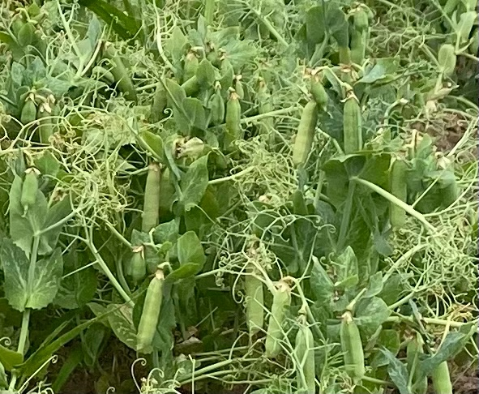

Description:
FP2269 is one of the earliest pea varieties which is important to start the canning process.

Disease Resistance:
Moderately Resistant to Aphanomyces, Pythium and Fusarium root rot diseases as well as to Powdery Mildew.



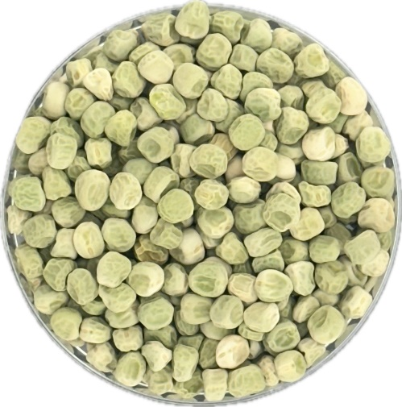
Green Pea Variety FP2269 Technical Data

Features and Advantages
- Early season Pea Variety
- Resistance to foliar diseases important
in the Midwest.
- Competitive Yield

Plant Characteristics:
Plant Height: 12.3” Vine Length: 13.1” Leaf Type: Afila
Vine Type: Determinant Foliage color: light green Pod color: Light green
Pods per node: 1-2 Pod Length: 1.92 in Berries per pod: 4.7

Plant Description:
FP2269 is one of the earliest shell pea varieties for planting, which is critical to start processing early in the year. Pods and berries are light green in color. The average berries sieve size of 4.36 while maintaining quality for freezing and canning.

Disease Responses: Susceptible to root rot but resistant Fusarium Wilt and foliar diseases including Powdery Mildew, Downy Mildew, Ascochyta Blight. It is similarly resistant to Pea Seedborne Mosaic Virus and Pea Enation Mosaic Virus.

Maturity (Average from early and late plantings):
Emergence: Normal HU to 1st Bloom: 712 HU to 80% Bloom: 755
HU to Maturity: 1250 Harvestability: Fair Sieve Size at Maturity: 4.36

Dry Seed Characteristics:
Seed Shape: Irregular Seed Surface: Dimpled Seed Luster: Dull Seed Color Pattern: Mottled Primary Color: Cream and green
Secondary Color: Medium green No. Seeds/lb: 2275

Green Pea Variety 435

Key Attributes:
- Early-season pea
- Competitive yield

Yield:
- Competitive yield and attractive sieve size averaging 3.8 in the Midwest over the years

Maturity:
- 10.4 nodes to first bloom
- 11.8 total nodes
- 1300 heat units to harvest

Plant Traits:
- Canopy height of 11”
- Total vine length of 11.3”
- Afila leaf type
- Typically, 2.2 pods per node, about 2.7” long, (longer than other early varieties)

Berries
- Average sieve size of 3.8
- Medium green color
- Number of berries/pod: 5.1
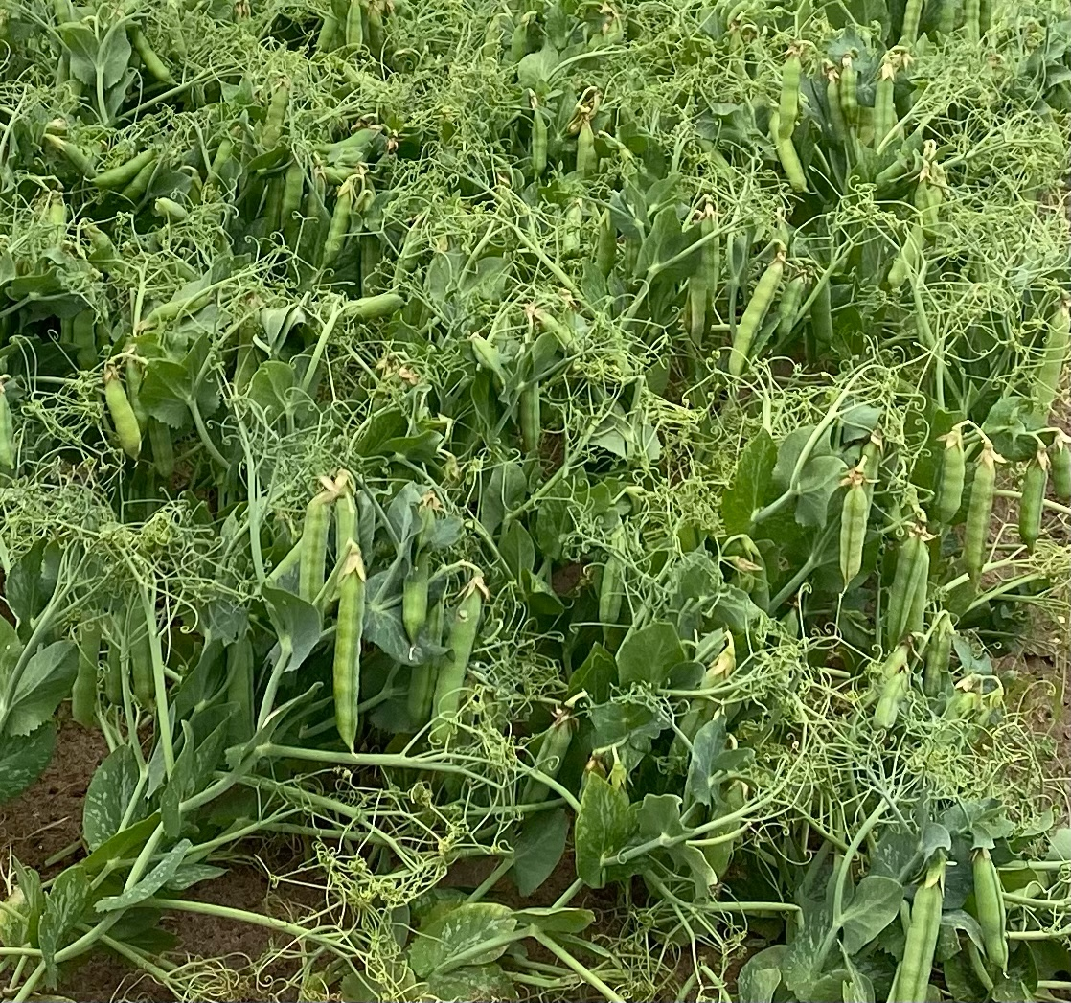

Description:
Early maturing variety, characterized by longer pods compared to other early varieties.

Resistance:
- Moderately resistant to Aphanomyces and Fusarium root rot, susceptible to Pythium seed rot.
- Tolerant to powdery mildew.

Green Pea Variety 435
Technical Data
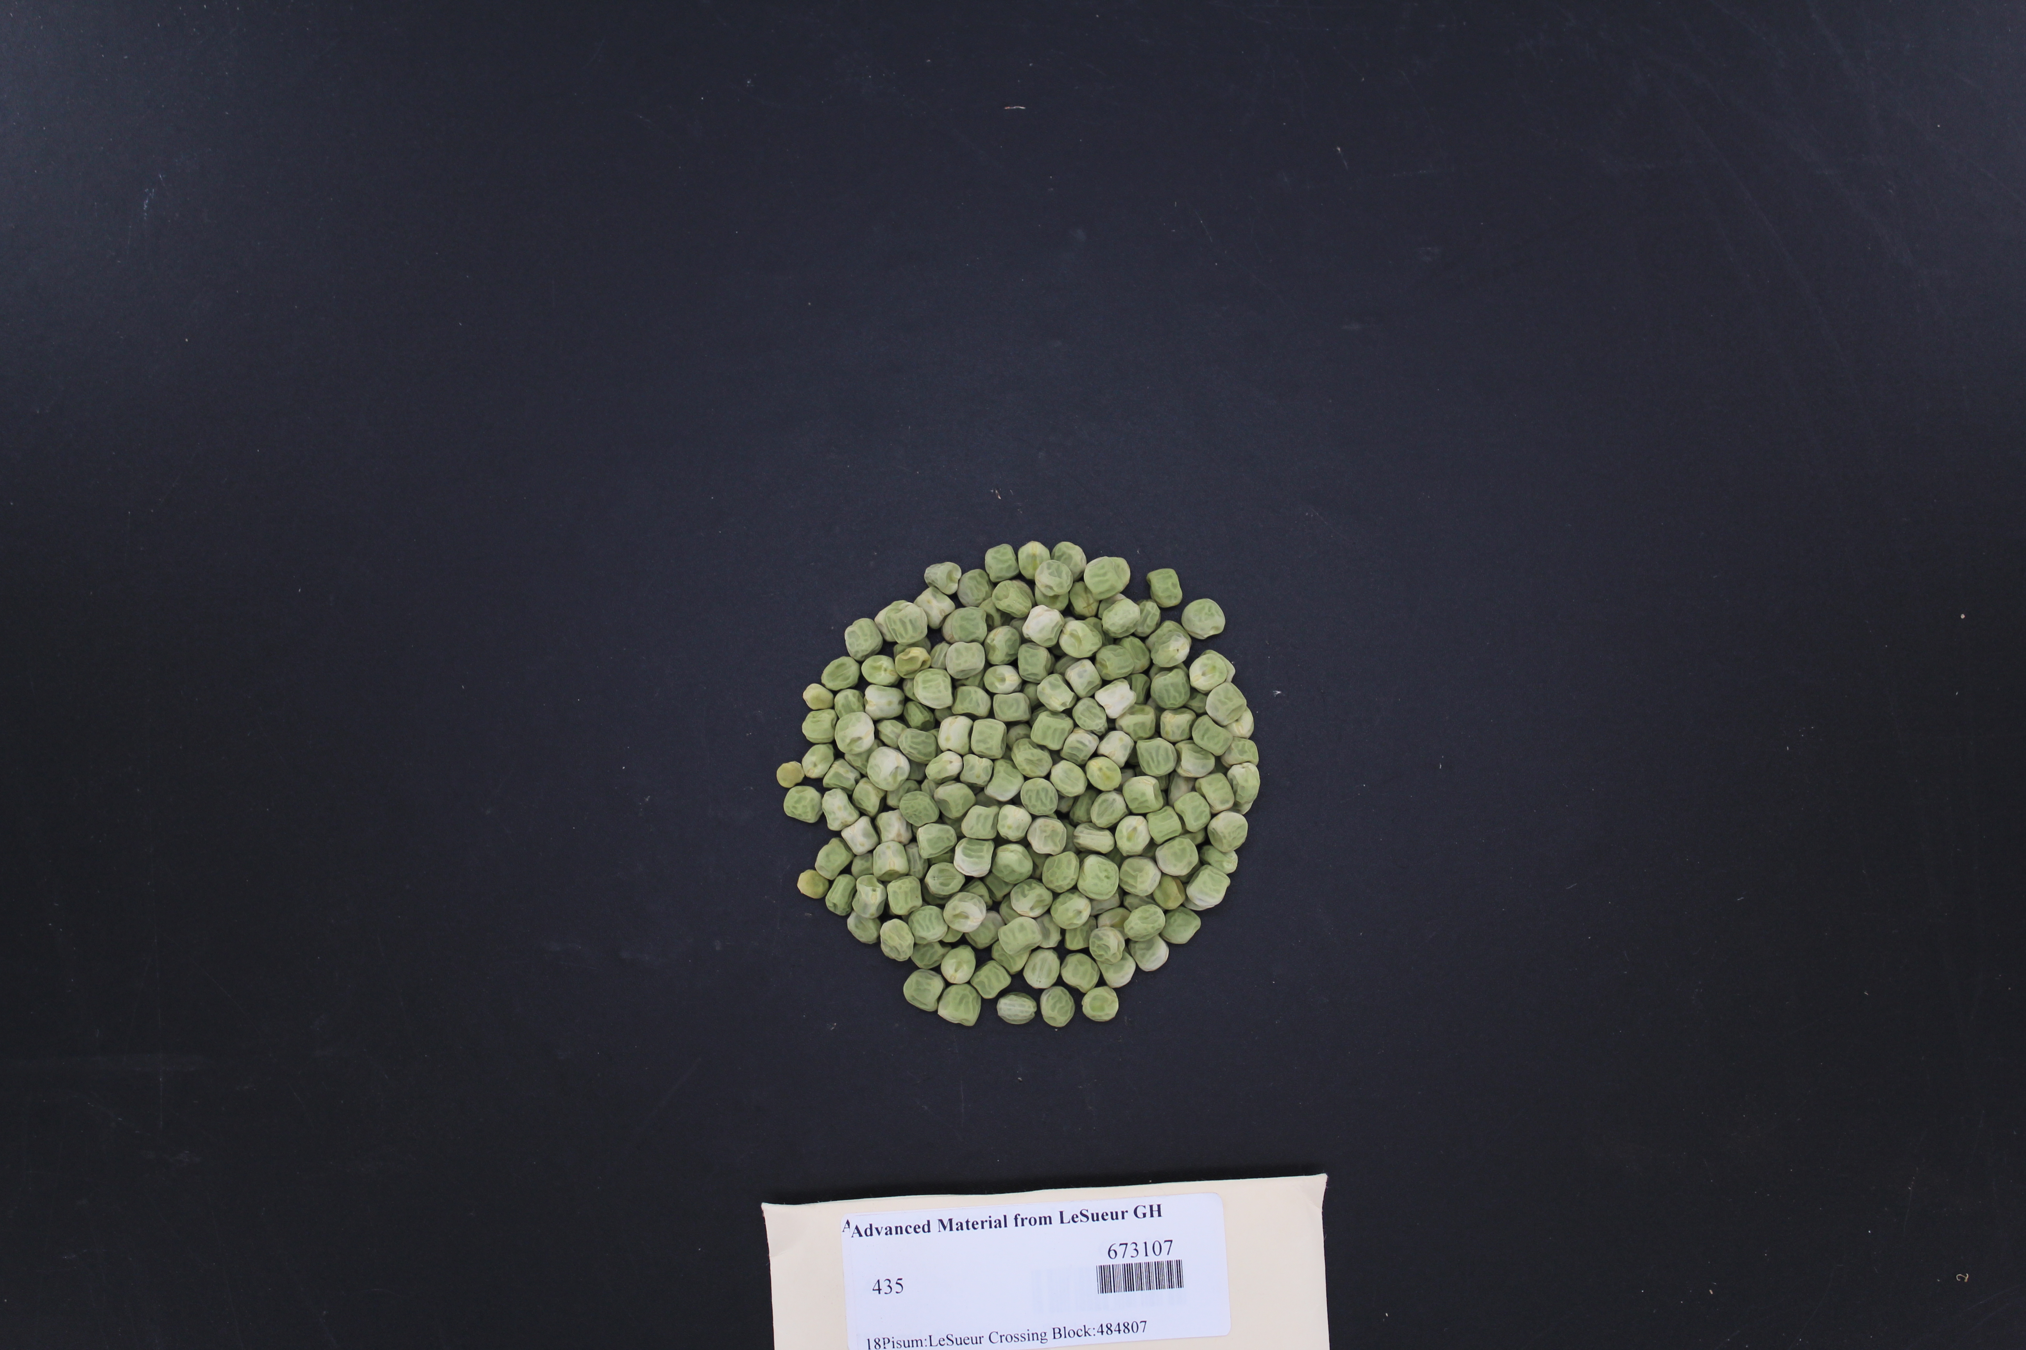

Features and Advantages
- Early-season pea variety
- Competitive yield
- Moderately resistant to root rot

Plant Characteristics:
Canopy Height: 11” Vine Length: 11.3” Leaf Type: Afila Vine Type: Indeterminant Foliage color: Medium Green Pod color: Medium Green Pods per node: 2.2 Pod Length: 2.7 in Berries per pod: 5.1

Plant Description:
435 is an early-season shell pea variety with good yield under good crop conditions. 435 possesses some resistance to root rot but it is susceptible to seed rot, which causes losses in plant stand. 435 berries are medium green in color with an average sieve size of 3.8 while maintaining high quality for freezing and canning.

Disease Responses: Moderately resistant to Aphanomyces and Fusarium root rot, susceptible to Pythium seed rot. Susceptible to Pea Seedborne Virus and Pea Enation Mosaic Virus

Maturity:
Emergence: Normal HU to 1st Bloom: 760 HU to 80% Bloom: 825
HU to Maturity: 1300 Harvestability: Good Sieve Size at Maturity: 3.8

Dry Seed Characteristics:
Seed Shape: Irregular Seed Surface: Wrinkled Seed Luster: Dull
Color Pattern: Mottled Primary Color: Medium green Secondary Color: Cream
No. Seeds/lb: 2360

Green Pea Variety Dakota

Key Attributes:
- One of the earliest varieties available
- Early-season standard leaf pea variety
- Competitive yield

Yield:
- Competitive yield and sieve size averaging 3.9 in the Midwest over the years

Maturity:
- 9.9 nodes to first bloom
- 11 total nodes
- 1250 heat units to harvest

Plant Traits:
- Determinant plant type
- Canopy height of 11”
- Total vine length of 13”
- Standard leaf type
- Typically, 2 pods per node, about 2.54” long

Berries
- Average sieve size of 3.9
- Medium green color
- Number of berries/pod: 4.6

Description:
Early maturing determinant variety of standard leaf type.

Resistance:
- Tolerant to powdery mildew.

Green Pea Variety Dakota
Technical Data

Features and Advantages
- Early-season pea variety
- Competitive yield
- Moderately resistant to root rot

Plant Characteristics:
Canopy Height: 11” Vine Length: 13” Leaf Type: Standard Vine Type: Determinant Foliage color: Medium Green Pod color: Medium Green Pods per node: 2 Pod Length: 2.54” Berries per pod: 4.6

Plant Description:
Dakota is an early-season standard leaf type shell pea variety with good yield. Dakota possesses tolerance to powdery mildew. Dakota berries are medium green in color with an average sieve size of 3.9 while maintaining freezing and canning quality.

Disease Responses: Tolerant to powdery mildew

Maturity:
Emergence: Normal HU to 1st Bloom: 720 HU to 80% Bloom: 760
HU to Maturity: 1250 Harvestability: Good Sieve Size at Maturity: 3.9

Dry Seed Characteristics:
Seed Shape: Irregular Seed Surface: Wrinkled Seed Luster: Dull
Color Pattern: Mottled Primary Color: Medium green Secondary Color: Cream
No. Seeds/lb: 2430

Green Pea Variety Austin

Key Attributes:
- Early-season leaf pea variety
- Competitive yield

Yield:
- Competitive yield and attractive sieve size averaging 4.1 in the Midwest over the years

Maturity:
- 10.3 nodes to first bloom
- 10.6 total nodes
- 1300 heat units to harvest

Plant Traits:
- Indeterminant plant type
- Canopy height of 11”
- Total vine length of 13”
- Afila leaf type
- Typically, 2 pods per node, about 2.14” long

Berries
- Average sieve size of 4.1
- Medium green color
- Number of berries/pod: 4.6

Description:
Early maturing indeterminant variety of afila leaf type.

Resistance:
- Tolerant to powdery mildew.

Green Pea Variety Austin
Technical Data

Features and Advantages
- Early-season pea variety
- Competitive yield
- Moderately resistant to root rot

Plant Characteristics:
Canopy Height: 11” Vine Length: 13” Leaf Type: Afila Vine Type: Indeterminant Foliage color: Medium Green Pod color: Medium Green Pods per node: 2 Pod Length: 2.14” Berries per pod: 4.6

Plant Description:
Austin is an early-season shell pea variety with good yield. Austin possesses tolerance to powdery mildew. Austin berries are medium green in color with an average sieve size of 4.1 while maintaining freezing and canning quality.

Disease Responses: Tolerant to powdery mildew, moderately resistant to root rot.

Maturity:
Emergence: Normal HU to 1st Bloom: 745 HU to 80% Bloom: 800
HU to Maturity: 1300 Harvestability: Good Sieve Size at Maturity: 4.1

Dry Seed Characteristics:
Seed Shape: Irregular Seed Surface: Wrinkled Seed Luster: Dull
Color Pattern: Monocolor Primary Color: Creamy white No. Seeds/lb: 2415

Green Pea Variety
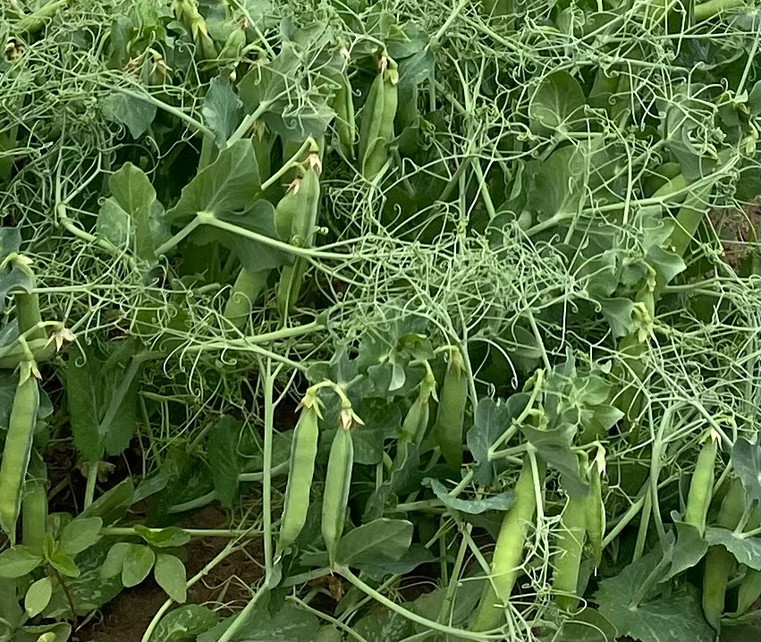
518
Key Attributes:
- 2nd Early variety
- Competitive yield, particularly under irrigated crops
- High level of resistance to Aphanomyces and Fusarium root rot and foliar diseases

Yield:
- Excelletn yield performer in Midwest trials and attractive sieve size averaging 3.99 over years tested.

Maturity:
- 12 nodes to first bloom
- 13 total nodes
- 1440 heat units to harvest

Plant Traits:
- Canopy height of 12.8”
- Vine length of 13.6”
- Afila leaf type
- Typically, 2-3 pods per node

Berries:
- Average sieve size of 3.99
- Medium green color

Description:
518 is a second early garden pea variety with superior yield. 518 possesses a solid root rot resistance and overall disease resistance package well suited against fungal pathogens in the Midwest and Pacific Northwest. The berries are medium green in color with an average sieve size of 3.99 while maintain high quality for freezing and canning.

Disease Resistance:
- High level of resistance to Aphanomyces and Fusarium root rot. Fusarium wilt resistant
- Powdery mildew resistant
- Resistant to Ascochyta Blight
- Resistant to Pea Enation Mosaic Virus

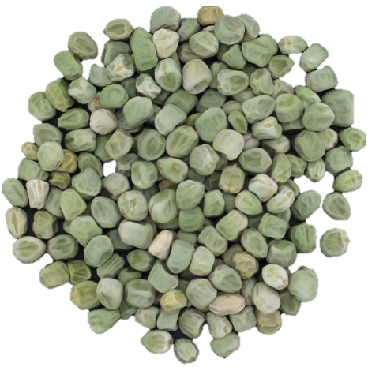
Green Pea Variety 518 Technical Data

Features and Advantages
• 2nd Early Garden shell pea variety
• Excelletn yields
• High level of resistance to root rot and foliar diseases

Plant Characteristics:
Plant Height: 12.8” Vine length: 13.6” Leaf Type: Afila
Vine Type: Indeterminant Foliage color: medium green Pod color: med. green
Pods per node: 2-3 Pod Length: 3” Berries per pod: 5.1

Plant Description:
518 is a second early garden pea with superior yield. 518 possesses a superior disease resistance package well suited against fungal pathogens in the Midwest and Pacific Northwest. The berries are medium green in color with an average sieve size of 3.99 while maintaining high freezing and canning quality.

Disease Responses: High level of resistance to Aphanomyces and Fusarium root rot, Powdery Mildew, Ascochyta Blight and Pea Enation Mosaic Virus

Maturity:
Emergence: Excellent HU to 1st Bloom: 937 HU to 80% Bloom: 960
HU to Maturity: 1440 Harvestability: Good Sieve Size at Maturity: 3.9

Dry Seed Characteristics:
Seed Shape: Oval Seed Surface: Wrinkled Seed Luster: Dull Seed Color Pattern: Bicolor Primary Color: Medium green
Secondary Color: Cream No. Seeds/lb: 2500

Green Pea Variety
8288
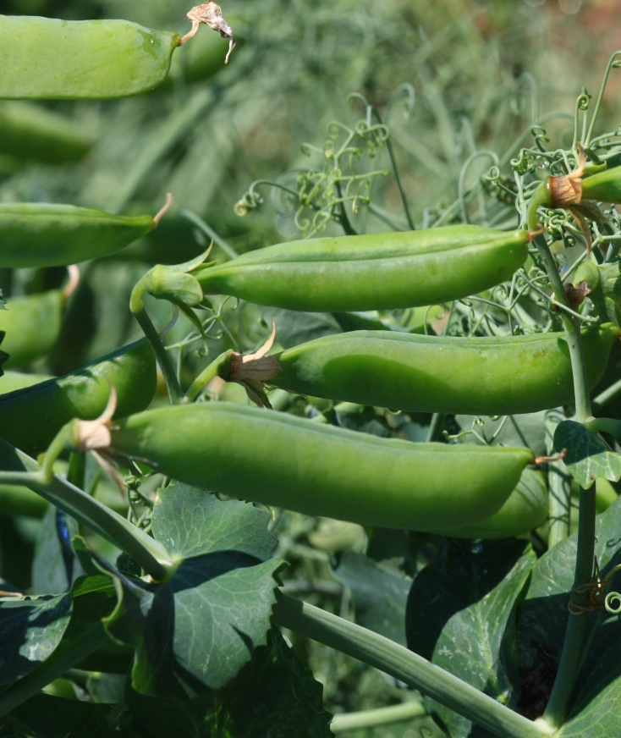
Key Attributes:
- Mid-season pea
- Excellent yield vs. other mid-season varieties
- Strong resistance to Aphanomyces and Fusarium root rot and foliar diseases

Yield:
- Excellent yield performer in Midwest trials and attractive sieve size averaging 3.9 over years.

Maturity:
- 13 nodes to first bloom
- 14.2 total nodes
- 1540 heat units to harvest

Plant Traits:
- Canopy height of 13”
- Vine length of 16.5”
- Afila leaf type
- Typically, 2-3 pods per node
- 2.2” pod length

Berries:
- Average sieve size of 3.9,
- Medium green color
- 5.6 berries/pod

Description:
8288 is a mid-season garden pea with superior yield. 8288 possesses an excellent disease resistance package well suited against fungal pathogens in the Midwest and Pacific Northwest. The berries are medium green in color with an average sieve size of 3.9 while maintain canning quality.

Disease Resistance:
- Strong resistance to Aphanomyces and Fusarium Root rot
- Fusarium wilt resistant
- Powdery and Downy mildew resistant
- Tolerance to Fusarium solani.

Garden Pea Variety 8288 Technical Data
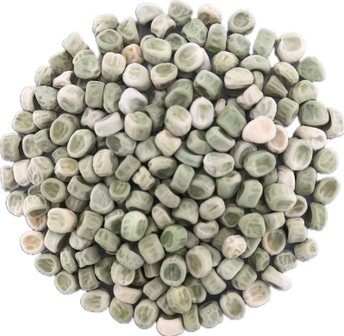

Features and Advantages
• Mid-season shell pea
• Excellent yield vs. other mid-season varieties
• Excellent disease resistance

Plant Characteristics:
Plant Height: 13” Leaf Type: Afila Vine Type: Indeterminant
Vine Length: 16.5” Foliage color: Dark green Pod color: Dark green Pods per node: 2-3 Pod Length: 2.2 in Berries per pod: 5.3

Plant Description:
8288 is a high yielding mid-season shell pea variety. 8288 shows excellent resistance to multiple diseases that make it well suited for production in the Midwest. Plant pods and berries are green in color. The average berry sieve size of 3.9 while maintaining freezing and canning quality.

Disease Responses: High level of resistance to Aphanomyces, Pythium and Fusarium Root Rot, Powdery Mildew, Downy Mildew and Pea Seedborne Mosaic Virus.

Maturity (Average from early and late plantings):
Emergence: Excellent HU to 1st Bloom: 910 HU to 80% Bloom: 970
HU to Maturity: 1540 Harvestability: Excellent Sieve Size at Maturity: 3.9

Dry Seed Characteristics:
Seed Shape: Flattened Seed Surface: Wrinkled Seed Luster: Dull Seed Color Pattern: Mottled Primary Color: Light green
Secondary Color: Creamy white No. Seeds/lb.: 2640

Green Pea Variety
Gallant
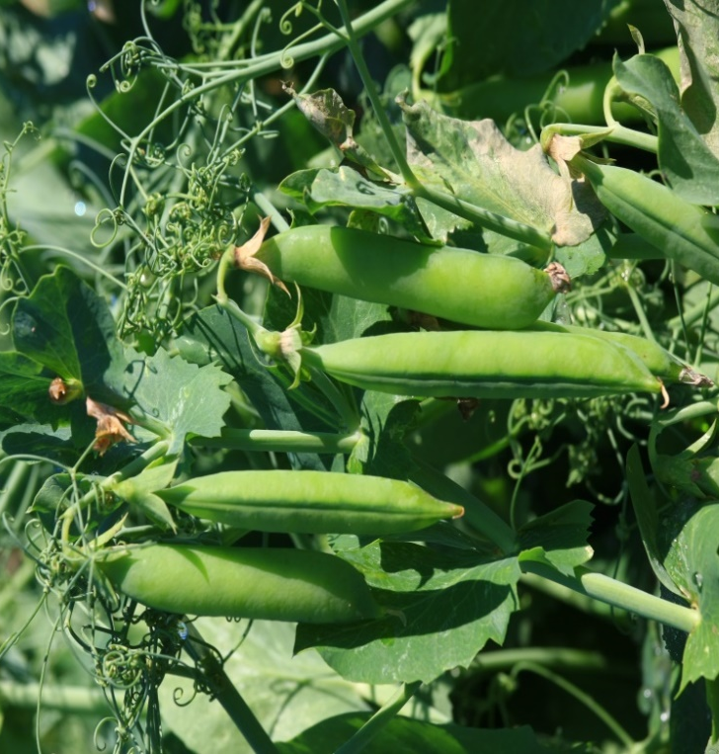
Key Attributes:
- Mid-season dark green shell pea
- Consistent yield
- Good disease resistance
- Tolerant to environmental stresses

Yield:
- Good yield performer in Midwest trials and sieve size averaging 3.7 over years tested.

Maturity:
- 13.4 nodes to first bloom
- 1540 heat units to harvest

Plant Traits:
- Canopy height of 10”
- Vine length of 11.9”
- Dark green foliage
- Afila leaf type
- Typically, 2 pods per node

Berries:
- Average sieve size of 3.7
- Dark green color

Description:
Gallant is a mid-season garden shell pea variety with good yield. Gallant possesses good root rot resistance and a good overall disease resistance package. The berries are dark green in color with an average sieve size of 3.7.

Disease Resistance:
- Aphanomyces and Fusarium Root rot tolerant and Fusarium wilt resistant
- Powdery Mildew resistant

Green Pea Variety Gallant Technical Data

Features and Advantages
• Mid-season Garden shell pea variety
• Consistent yields
• Good resistance to root rot and foliar diseases

Plant Characteristics:
Plant Height: 10” Leaf Type: Afila Vine Length: 11.9” Vine Type: Indeterminant Foliage color: dark green Pod color: dark green Pods per node: 2 Pod Length: 2.7 in Berries per pods: 5.4

Plant Description:
Gallant is a mid-season garden shell pea variety with good yield and disease tolerance. Gallant possesses a superior disease resistance package well suited against fungal pathogens in the Midwest. The berries are dark green in color with an average sieve size of 3.7 while maintaining good freezing and canning quality.

Disease Responses: Good resistance to Aphanomyces and Fusarium root rot and Powdery Mildew

Maturity:
Emergence: Normal HU to 1st Bloom: 940 HU to 80% Bloom: 1008
HU to Maturity: 1540 Harvestability: Excellent Sieve Size at Maturity: 3.7

Dry Seed Characteristics:
Seed Shape: Irregular Seed Surface: Wrinkled Seed Luster: Dull Seed Color Pattern: Bicolor Primary Color: Medium green Secondary Color: Cream No. Seeds/lb.: 2820

Green Pea Variety
Ricco
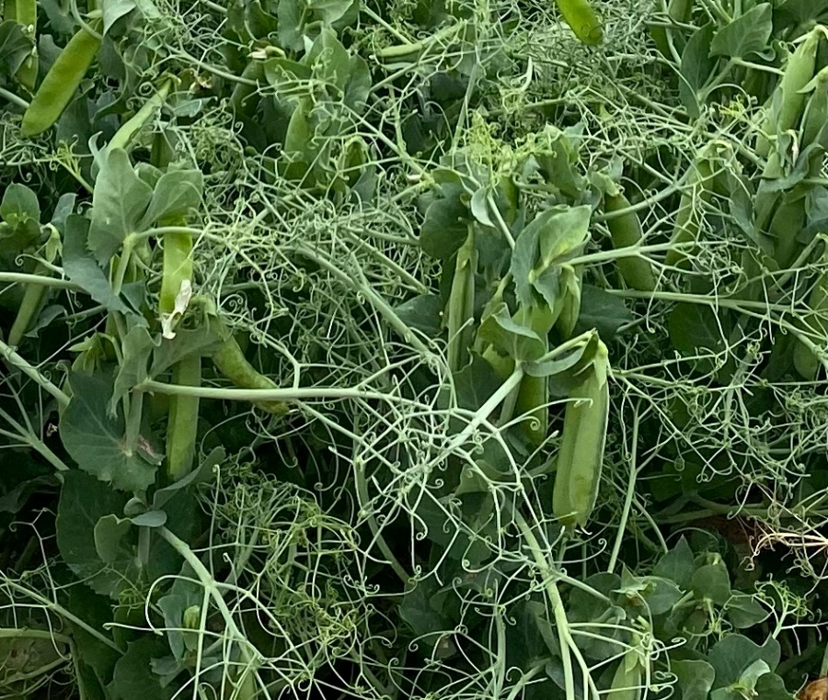
Key Attributes:
- Mid-season green shell pea
- Excellent yield
- Strong resistance to Aphanomyces and Fusarium root rot and foliar diseases

Yield:
- Excellent yield performer in Midwest trials and sieve size averaging 4.3 over years tested.

Maturity:
- 14 nodes to first bloom
- 1575 heat units to harvest

Plant Traits:
- Canopy height of 14.1”
- Vine length of 16”
- Afila leaf type
- High tolerance to Heat Stress
- Typically, 2 pods per node

Berries:
- Average sieve size of 4.3
- Medium green color

Description:
Ricco is a mid-season garden shell pea variety with superior yield. Ricco possesses a solid root rot resistance and overall disease resistance package and heat tolerance making it well adapted to both the Midwest and PNW. The berries are medium green in color with an average sieve size of 4.3.

Disease Resistance:
- Aphanomyces and Fusarium Root rot resistant and Fusarium wilt resistant
- Powdery and Downy Mildew resistant
- Resistant to Pea Enation and Seedborne Mosaic Virus

Green Pea Variety Ricco Technical Data
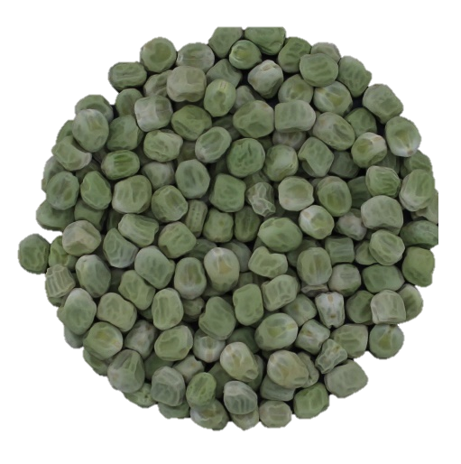

Features and Advantages
• Mid-season Garden shell pea variety
• Excellent yields
• Resistant to root rot and foliar diseases

Plant Characteristics:
Plant Height: 14.1” Vine Length: 16.0” Leaf Type: Afila
Vine Type: Indeterminant Foliage color: medium green Pod color: medium green
Pods per node: 2 Pod Length: 2.9 in Berries per pod: 5.4

Plant Description:
Ricco is a mid-season garden shell pea variety with superior yield and high tolerance to heat stresses, particularly when under irrigation. Ricco possesses a superior disease resistance package well suited against fungal pathogens in the Midwest and PNW. The berries are medium green in color with an average sieve size of 4.22 while maintaining high quality for freezing and canning.

Disease Responses: High level of resistance to Aphanomyces and Fusarium root rot, Powdery and Downy Mildew, Pea Enation Mosaic Virus, and Pea Seedborne Virus

Maturity:
Emergence: Excellent HU to 1st Bloom: 955 HU to 80% Bloom: 1008
HU to Maturity: 1575 Harvestability: Excellent Sieve Size at Maturity: 4.3

Dry Seed Characteristics:
Seed Shape: Irregular Seed Surface: Wrinkled Seed Luster: Dull Seed Color Pattern: Bicolor Primary Color: Medium green Secondary Color: Cream No. Seeds/lb.: 2120

Garden Pea Variety
FP2278
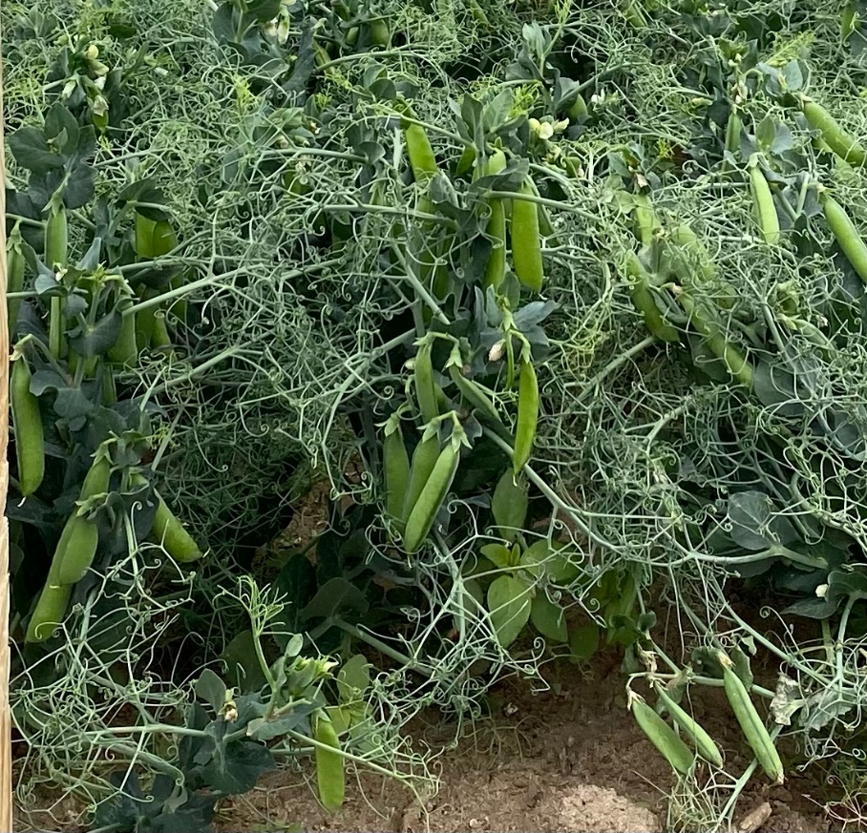
Key Attributes:
- Excellent yield
- Strong resistance to Aphanomyces, Pythium and Fusarium root rot diseases as well as to foliar diseases.

Yield:
- Excellent yield, with berry sieve size averaging a 4.2 over years tested in the Midwest.

Maturity:
- 13 nodes to first bloom
- 15 total nodes
- 1590 heat units to harvest

Plant Traits:
- Canopy height of 13”
- Vine length of 15”
- Afila leaf type
- Typically, 2 pods per node
- 2.6” long pods
- Dark Green Foliage

Berries:
- Average sieve size of 4.2
- Dark green color
- 5.6 berries/pod

Description:
FP2278 is a mid-season pea variety with superior yield with an average sieve size of 4.2 while maintaining freezing and canning quality. FP2278 possesses an excellent root rot and overall disease package for the Midwest and PNW. It shows a characteristic dark plant color.

Disease Resistance:
- Strong resistance to Aphanomyces, Pythium and Fusarium root rot diseases as well as to foliar diseases
- Resistant to Powdery Mildew

Garden Pea Variety FP2278 Technical Data

Features and Advantages
- Mid Season shell pea
- Competitive yield
- Excellent Disease Resistance
- Average sieve size of 4.2 with good canning quality

Plant Characteristics:
Plant Height: 13” Vine Length: 15” Leaf Type: Afila
Vine Type: Indeterminant Foliage color: dark green Pod color: Dark green
Pods per node: 2 Pod Length: 2.6” Berries per pods: 5.6

Plant Description:
FP2278 is a mid-season shell pea with competitive yield. FP2278 shows excellent resistance to multiple diseases that make it well suited for production in the Midwest. Plant pods and berries are green in color. The average berry sieve size of 4.2 while maintaining freezing and canning quality.

Disease Responses: High level of resistance to Aphanomyces, Pythium and Fusarium Root Rot, Powdery Mildew, Downy Mildew and Pea Seedborne Mosaic Virus.

Maturity (Average from early and late plantings):
Emergence: Excellent HU to 1st Bloom: 920 HU to 80% Bloom: 992
HU to Maturity: 1590 Harvestability: Excellent Sieve Size at Maturity: 4.2

Dry Seed Characteristics:
Seed Shape: Flattened Seed Surface: Wrinkled Seed Luster: Dull Seed Color Pattern: Mottled Primary Color: Light green
Secondary Color: Creamy white No. Seeds/lb.: 2590

Green Pea Variety
522
Key Attributes:
- Excellent yield
- Strong resistance to Aphanomyces, Pythium and Fusarium root rot diseases as well as to foliar diseases.

Yield:
- Excellent yield with sieve size averaging 4.08 over years tested.

Maturity:
- 14.1 nodes to first bloom
- 1625 heat units to harvest

Plant Traits:
- Canopy height of 16.1”
- Afila leaf type
- Typically 3 pods per node
- 2.65” pod length

Berries:
- Average sieve size of 4.08
- Medium green color
- 5.4 berries/pod
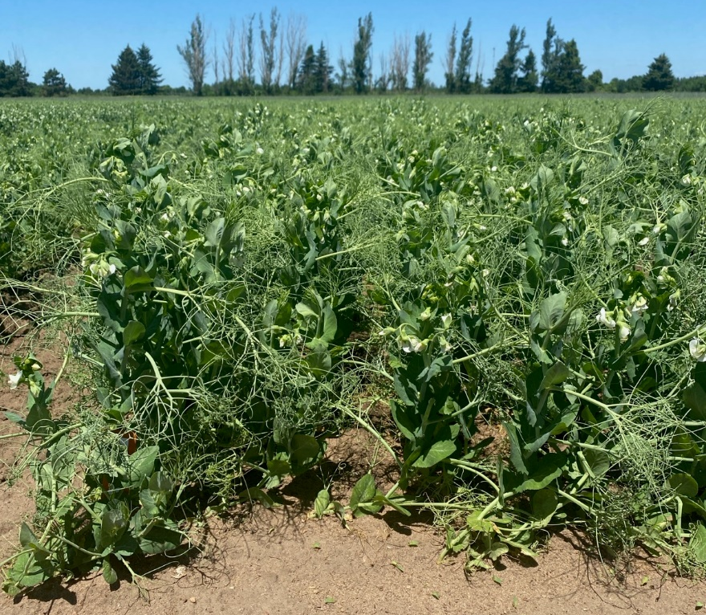

Description:
522 is a mid-season pea variety with superior yield with an average sieve size of 4.08 while maintaining excellent quality for freezing and canning.
522 possesses an excellent root rot and overall disease package for the Midwest.

Disease Resistance:
- Strong resistance to Aphanomyces, Pythium and Fusarium root rot diseases as well as to foliar diseases.
- Strong resistance to Powdery Mildew.

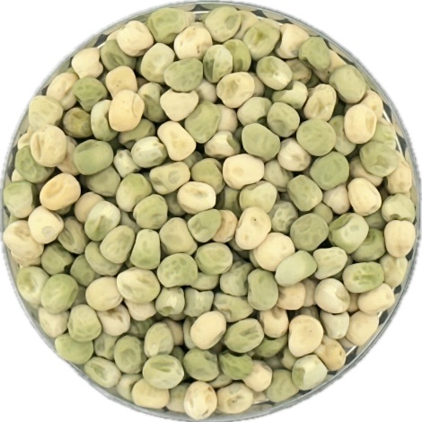
Green Pea Variety 522 Technical Data

Features and Advantages
• Excellent yield
• Average sieve size of 4.08 with excellent freezing and
canning quality

Plant Characteristics:
Plant Height: 16.1’ Leaf Type: Afila
Vine Type: Indeterminant Foliage color: green Pod color: Medium green
Pods per node: 3 Pod Length: 2.65 in Berries per pods: 5.4

Plant Description:
522 is a mid-season shell pea with superior yield. 522 possesses a combination of disease resistance that makes it well suited for production in the Midwest. The berries are green in color with an average sieve size of 4.08 while maintaining quality for freezing and canning.

Disease Responses: Strong resistance to Aphanomyces, Pythium and Fusarium root rot diseases. It is also resistant to Powdery Mildew and Moderately resistant to Downy Mildew.

Maturity (Average from early and late plantings):
Emergence: Normal HU to 1st Bloom: 1048 HU to 80% Bloom: 1105
HU to Maturity: 1625 Harvestability: Good Sieve Size at Maturity: 4.08

Dry Seed Characteristics:
Seed Shape: Rounded Seed Surface: Wrinkled Seed Luster: Dull Seed Color Pattern: Bicolor Primary Color: Light green
Secondary Color: Creamy white No. Seeds/lb: 2160

Mini Shell Pea Variety
129
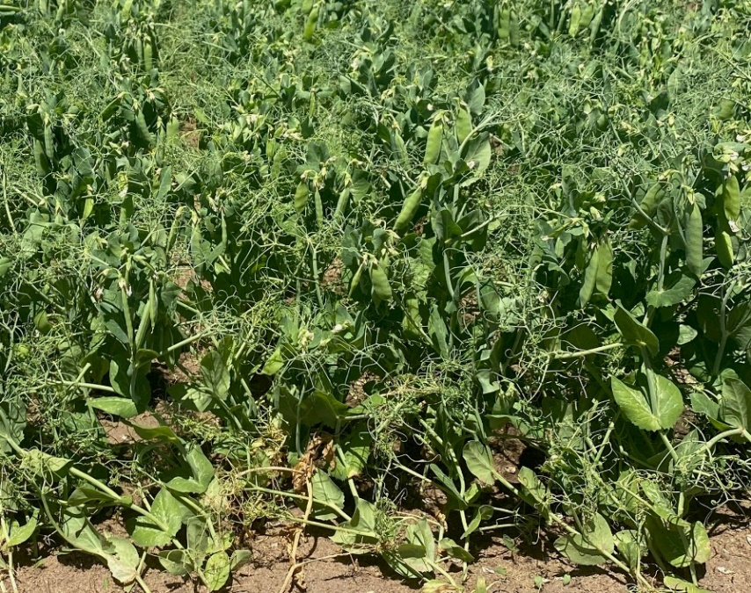
Key Attributes:
- Earliest mini shell pea variety
- Small sieve size of 2.12
- Responds well to irrigation

Yield:
- Good yield, commensurate with its early maturity.

Maturity:
- 11 nodes to first bloom
- 12.8 total nodes
- 1275 heat units to harvest

Plant Traits:
- Canopy height of 11.3”
- Vine length of 11.6”
- Afila leaf type
- Typically, 2-3 pods per node
- 1.81” long pods

Berries:
- Average sieve size of 2.12 with excellent quality
- Medium green color
- 5.1 berries/pod

Description:
129 is a mini pea variety with good yield with an average sieve size of 2.12 while maintaining high quality for processing.

Disease Resistance:
- Resistant to Downy Mildew and Ascochyta Blight.
- Moderately susceptible to Aphanomyces Root Rot and resistant to Fusarium Root Rot.
- Susceptible to Powdery Mildew, but because of its earliness may escape this disease.
- Susceptible to Pea Enation Mosaic Virus and Pea Seedborne Mosaic Virus.

Mini Shell Pea Variety 129 Technical Data

Features and Advantages
• Good yield, commensurate with its early maturity
• Average sieve size of 2.12 with excellent processing quality

Plant Characteristics:
Plant Height: 11.3” Vine length: 11.6” Leaf Type: Afila
Vine Type: Indeterminant Foliage color: medium green Pod color: Medium green
Pods per node: 2-3 Pod Length: 1.81 in Berries per pods: 5.1

Plant Description:
129 is a mini shell pea with good yield commensurate with its earliness. 129 possesses a combination of maturity and disease reactions that make it suited for production in the Midwest. The berries are green in color with an average sieve size of 2.12 while maintaining quality for processing.

Disease Responses: Resistance to Downy Mildew and Ascochyta Blight; Susceptible to Powdery Mildew, but it may escape this disease due to its earliness. It is also susceptible to Pea Enation Mosaic Virus and Pea Seedborne Mosaic Virus.

Maturity:
Emergence: Normal HU to 1st Bloom: 780 HU to 80% Bloom: 865
HU to Maturity: 1275 Harvestability: Good Sieve Size at Maturity: 2.12

Dry Seed Characteristics:
Seed Shape: Cylindrical Seed Surface: Dimpled Seed Luster: Dull Seed Color Pattern: Monocolor Primary Color: Creamy white
Secondary Color: Light Green No. Seeds/lb: 3870

Mini Shell Pea Variety
389
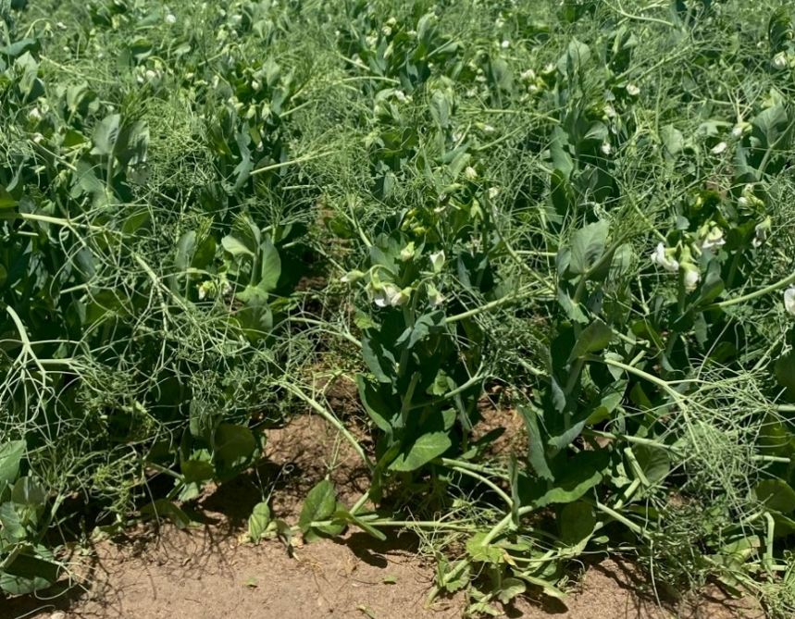
Key Attributes:
- 2nd early mini shell pea
- Excellent yield
- High level of resistance to Aphanomyces, Pythium and Fusarium root rot diseases.

Yield:
- Excellent yield with sieve size averaging 2.96 over years tested.

Maturity:
- 12.4 nodes to first bloom
- 14.2 total nodes
- 1500 heat units to harvest

Plant Traits:
- Canopy height of 15”
- Vine length of 16”
- Afila leaf type
- Typically, 2-3 pods per node
- 2.17” long pods

Berries:
- Average sieve size of 2.96 with good canning quality
- Medium green color
- 4.8 berries/pod

Description:
389 is a mini pea variety with excellent yield with an average sieve size of 2.96 while maintain high quality for freezing and canning.

Disease Resistance:
- High level of resistance to Aphanomyces, Pythium and Fusarium root rot diseases.
- Powdery mildew susceptible but it may be early enough to escape powdery mildew which may occur later in the season. Fungicide is required if planted late in the season.

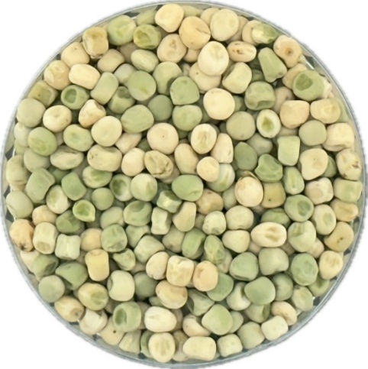
Mini Shell Pea Variety 389 Technical Data

Features and Advantages
• 2nd early mini shell pea
• Excellent yields
• Average sieve size of 2.96 with good processing quality

Plant Characteristics:
Plant Height: 15” Vine length: 16” Leaf Type: Afila
Vine Type: Indeterminant Foliage color: green Pod color: Green
Pods per node: 2-3 Pod Length: 2.17” Berries per pods: 4.8

Plant Description:
389 is a 2nd early mini shell pea with superior yield. 389 possesses a combination of maturity and disease reactions that make it well suited for production in the Midwest. The berries are green in color with an average sieve size of 2.96 while maintaining high freezing and canning quality.

Disease Responses: High level of resistance to Aphanomyces and Fusarium root rot in the field; Susceptible to Powdery Mildew, Ascochyta Blight, Pea Enation Mosaic Virus, and Pea Seedborne Mosaic Virus.

Maturity:
Emergence: Normal HU to 1st Bloom: 896 HU to 80% Bloom: 950
HU to Maturity: 1500 Harvestability: Good Sieve Size at Maturity: 2.96

Dry Seed Characteristics:
Seed Shape: Cylindrical Seed Surface: Dimpled Seed Luster: Dull Seed Color Pattern: Mostly bicolor Primary Color: Medium green
Secondary Color: Creamy white No. Seeds/lb: 3320

Mini Shell Pea Variety
322
Key Attributes:
- Excellent yielding full season mini
- High level of resistance to Aphanomyces, Pythium and Fusarium root rot diseases.

Yield:
- Excellent yield with sieve size averaging 2.60 over years tested.

Maturity:
- 13.9 nodes to first bloom
- 15.7 total nodes
- 1655 heat units to harvest

Plant Traits:
- Canopy height of 12.8”
- Vine length of 16.7”
- Afila leaf type
- Typically, 2-3 pods per node
- 2.19” long pods

Berries:
- Average sieve size of 2.60 with good canning quality
- Medium green color
- 5.9 berries/pod

Description:
322 is a full season mini pea variety with superior yield with an average sieve size of 2.60 while maintain high canning quality.

Disease Resistance:
- High level of resistance to Aphanomyces, Pythium and Fusarium root rot diseases.
- Resistant to Powdery Mildew

Mini Shell Pea Variety 322 Technical Data
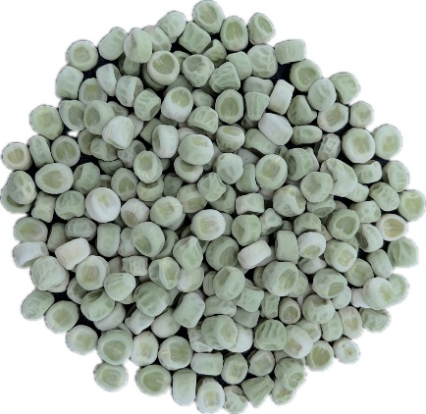

Features and Advantages
• Full Season mini shell pea
• Excellent yields
• Average sieve size of 2.60 with good processing quality

Plant Characteristics:
Plant Height: 15” Vine length: 16” Leaf Type: Afila
Vine Type: Indeterminant Foliage color: green Pod color: Green
Pods per node: 2-3 Pod Length: 2.19” Berries per pods: 5.9

Plant Description:
322 is a full season mini shell pea with superior yield. 322 possesses a combination of maturity and disease reactions that make it well suited for production in the Midwest. The berries are green in color with an average sieve size of 2.60 while maintaining high freezing and canning quality.

Disease Responses: High level of resistance to Pythium, Aphanomyces and Fusarium root rot in the field; it is also resistant to powdery mildew.

Maturity:
Emergence: Excellent HU to 1st Bloom: 1035 HU to 80% Bloom: 1095
HU to Maturity: 1655 Harvestability: Good Sieve Size at Maturity: 2.60

Dry Seed Characteristics:
Seed Shape: Cylindrical Seed Surface: Dimpled Seed Luster: Dull Seed Color Pattern: Mostly monocolor Primary Color: Medium green
Secondary Color: Cream No. Seeds/lb: 3670

